Java & JavaFX Installation and Configuration
CSD402 Module 1 Assignment
Instructor: Darrell Payne
Student Name: Zachary White
Date: June 7, 2026
Assignment: Module 1 CSD402

Overview
This document demonstrates the successful installation and configuration of the Java Development Kit (JDK) and the JavaFX SDK on a Windows machine, as well as the development and execution of a JavaFX application in Visual Studio Code. Each section below includes a screenshot and a description of what was verified at that step.

Step 1 Java JDK Installation Verified

What was done
The Java Development Kit (JDK) 26.0.1 was downloaded from the official Oracle website and installed to C:\Program Files\Java\jdk-26.0.1. To verify the installation, the javac -version command was run in a Windows Command Prompt, confirming the compiler is accessible system-wide and the correct version is active.
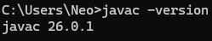
The output confirms JDK 26.0.1 is correctly installed and the javac compiler is available on the system PATH.

Step 2 JavaFX SDK Installed and Located

What was done
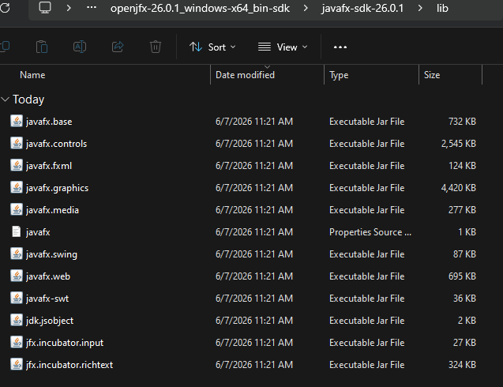
The JavaFX SDK 26.0.1 for Windows x64 was downloaded from GluonHQ and extracted to C:\CSD\CSD402\openjfx-26.0.1_windows-x64_bin-sdk\javafx-sdk-26.0.1. The lib subfolder contains the required .jar and .dll files including javafx.controls.jar, javafx.fxml.jar, and the native graphics libraries needed at runtime.

The JavaFX SDK is stored separately from the JDK, which is standard practice since JDK 11 when JavaFX was decoupled from the core Java distribution.

Step 3 VS Code Project Configured

What was done
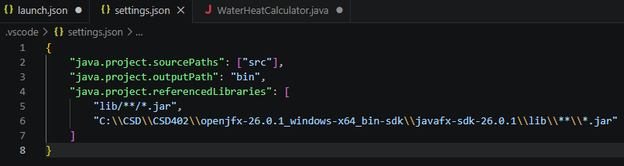
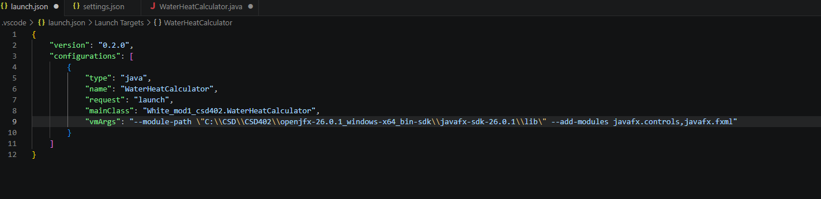
Visual Studio Code was configured with the Extension Pack for Java (Red Hat). Two project configuration files were created inside the .vscode folder of the project. The settings.json file points the Java language server to the JavaFX SDK jars so that imports resolve correctly during editing. The launch.json file passes the required --module-path and --add-modules flags to the JVM at runtime so JavaFX can be loaded.

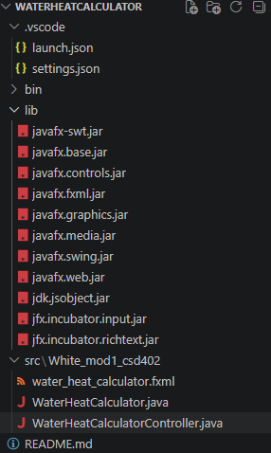
Step 4 Project Structure

What was done
The project follows a standard MVC (Model-View-Controller) pattern with the source files organized under src/White_mod1_csd402/. The three key files are the application entry point, the controller class that handles all business logic, and the FXML file that defines the UI layout declaratively. This separation of concerns keeps the code organized and maintainable.
Step 5 | Application Running Successfully

What was done
The application was compiled using javac with the JavaFX module path and then launched using java with the same module path. The JavaFX window opened successfully, displaying the Water Heat Energy Calculator interface with three input fields for water mass, initial temperature, and final temperature, along with Calculate Energy and Clear buttons.
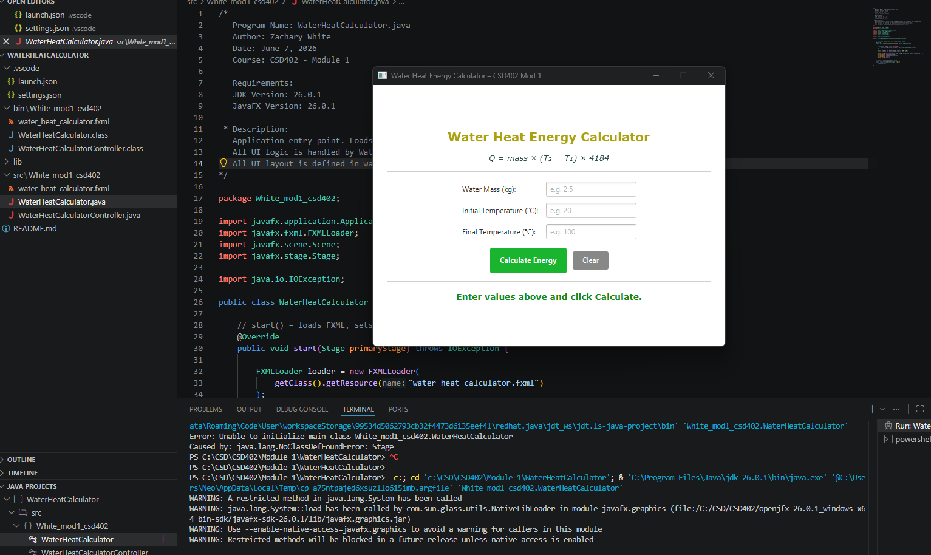

Step 6 | Calculation Demonstrated

What was done
To verify the application functions correctly, a test calculation was performed using the following inputs:
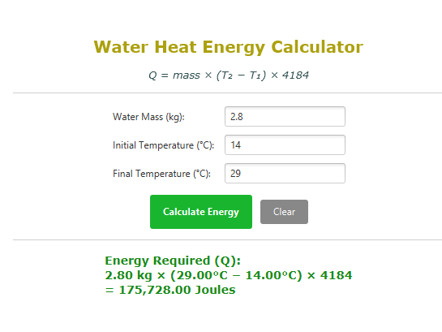
Water Mass: 2.8 kg Initial Temp: 14°C Final Temp: 29°C
The expected result using the formula Q = 2.8 × (29 − 14) × 4184 is 175,728.00 Joules. The application displayed this result correctly, confirming the formula and input validation are working as I had intended.

Summary
The following components were successfully installed and configured:
- JDK 26.0.1 installed and verified via javac -version
- JavaFX SDK 26.0.1 extracted and referenced in VS Code settings
- VS Code launch.json configured with correct --module-path and --add-modules flags
- Project structured using MVC pattern with FXML and Controller
- Application compiled and launched successfully from the terminal
- Water heat energy formula Q = mass × ΔT × 4184 verified with test input

